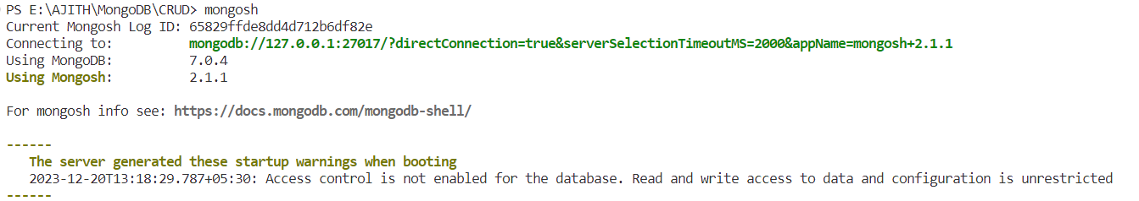



1. **Show Database List**

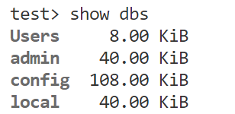



1. **Create Database**





1. **Insert Data**

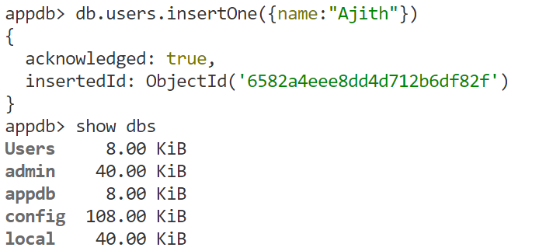



**Insert Nested Data**

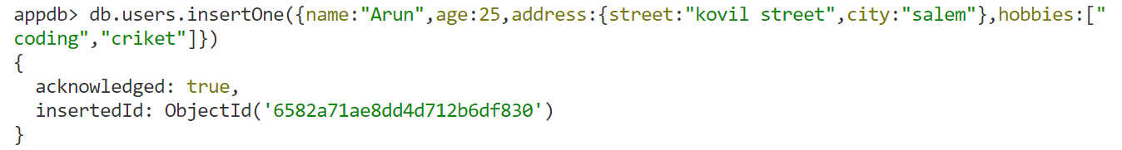



1. **Show data**

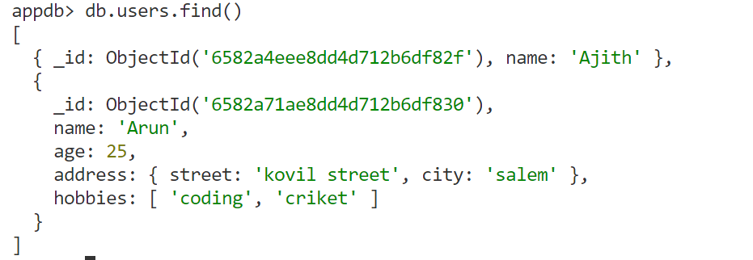



1. **Add multiple data document**

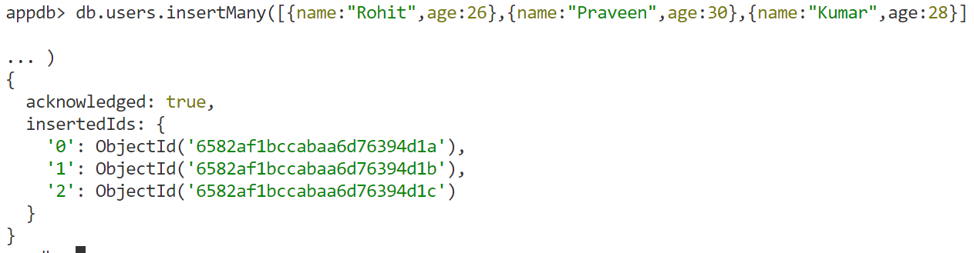



**Limit Method**

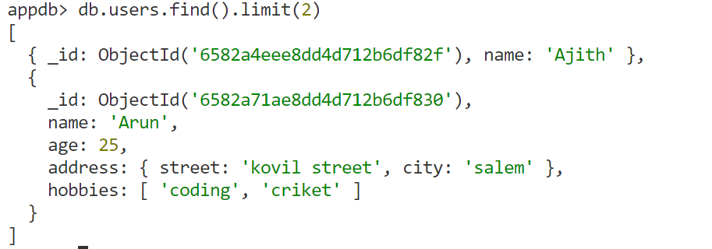



1. **Sort data**

**Ascending order (A to Z)**



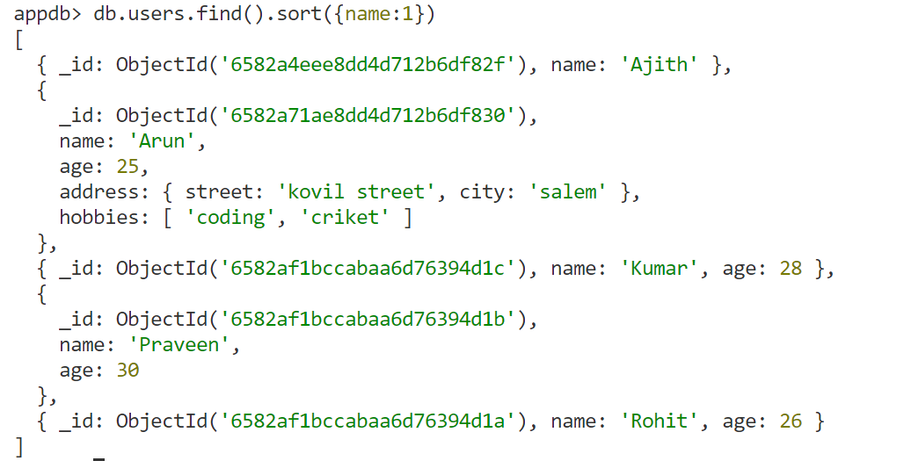



**Descending Order**

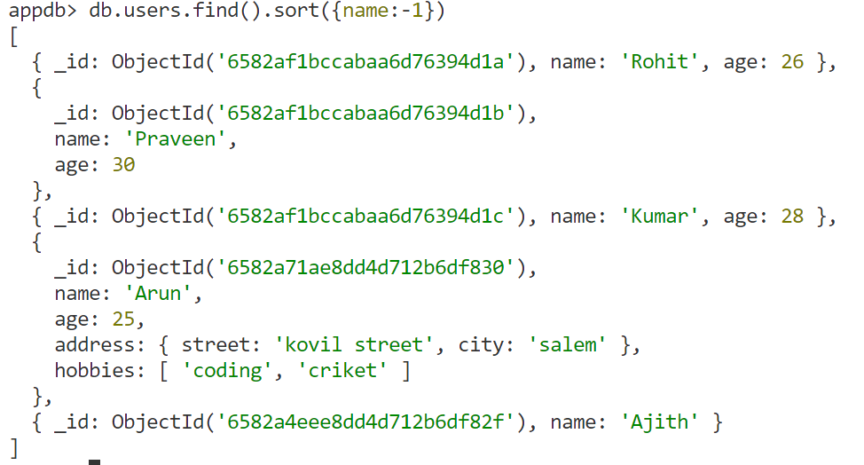



**Sort and Limit**

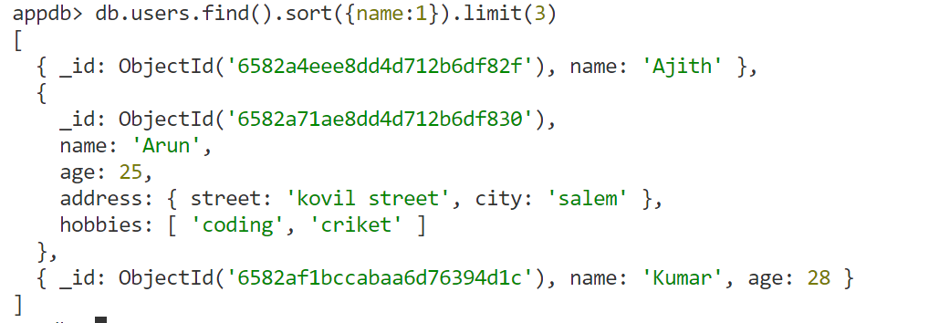



**Multiple sort**

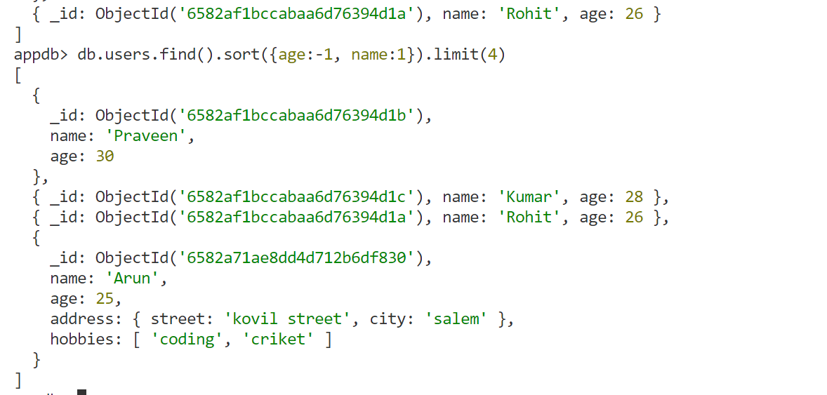



1. **Skip**

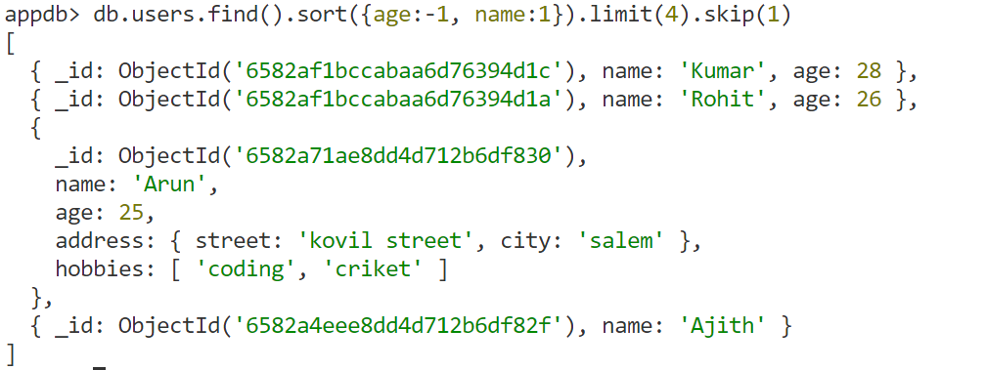



1. **Finding by value**

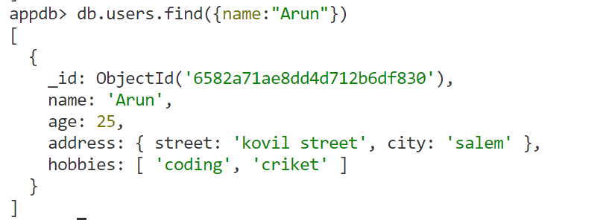



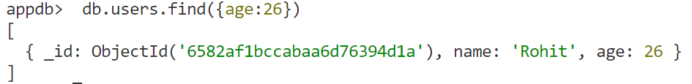

**To Show Selected Data**

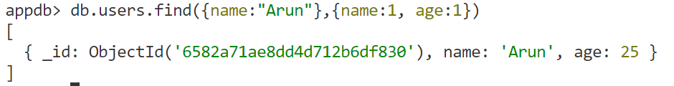



**Don’t show default Id**





1. **Complex Quires**
2. **Equal to $eq**

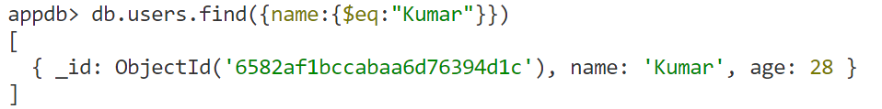



1. **In to $in ($in needs an array)**

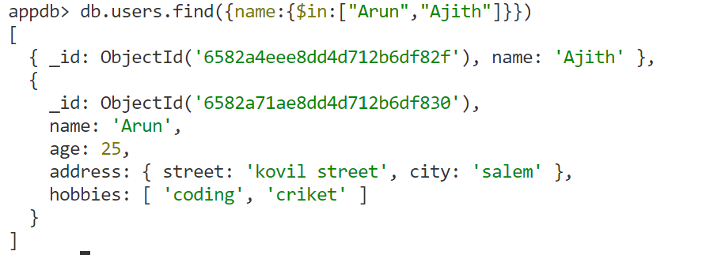



1. **Not in $nin**

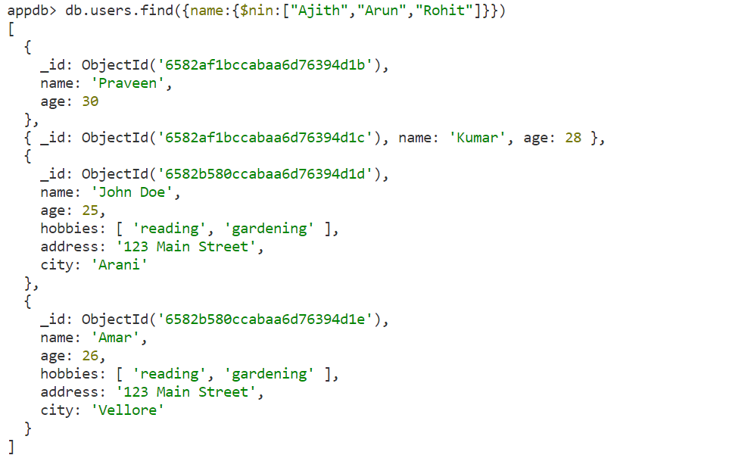



1. **Greater than** **$gt**

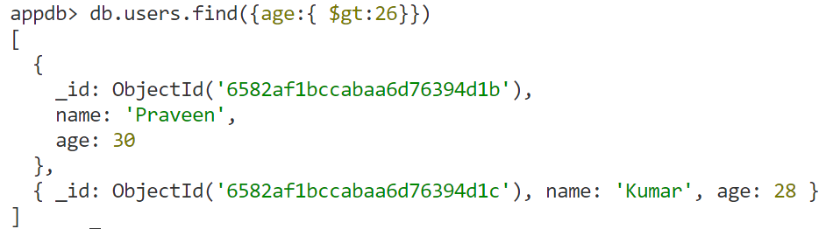



1. **Greater than or equal to** **$gte**

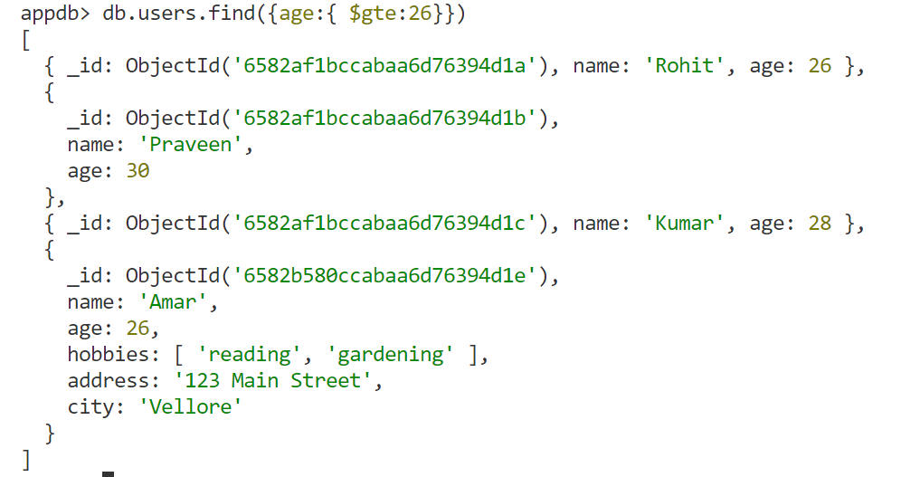



1. **Less than** **$lt**

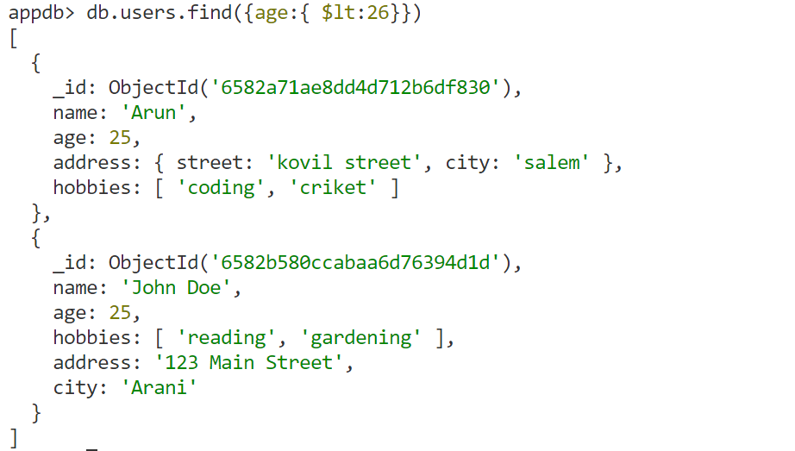



1. **Less than or equal to $lte**

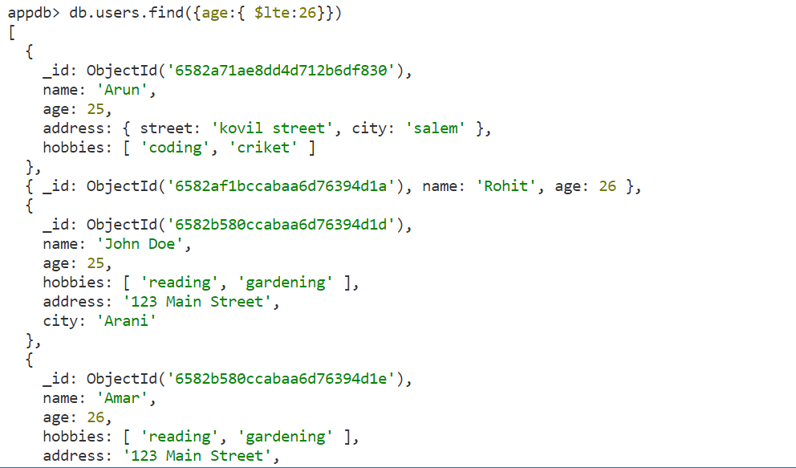



1. **Not equal to $ne**

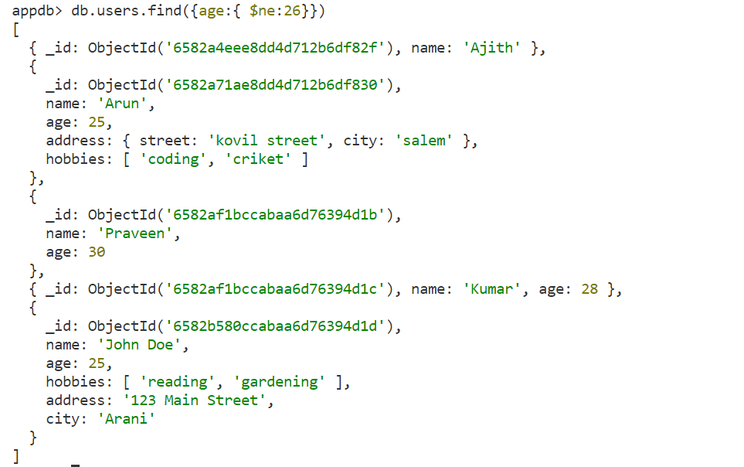



1. **Range between**

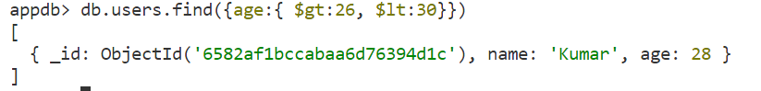



1. **Exists $exists**

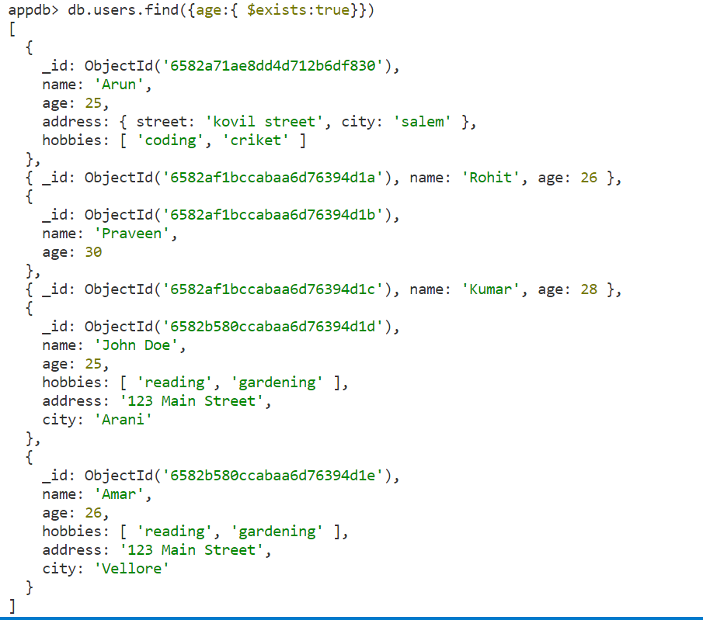



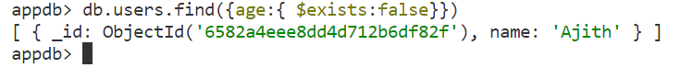

1. **Logical Operations**
2. **And**

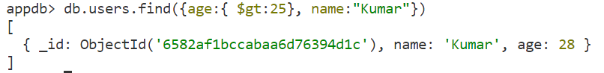



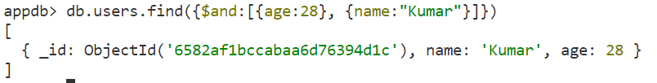

1. **OR**

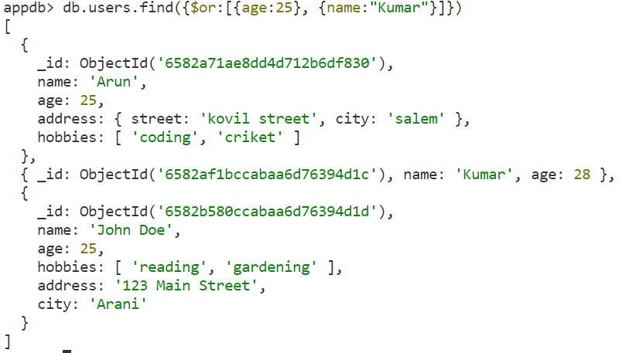



1. **NOT**

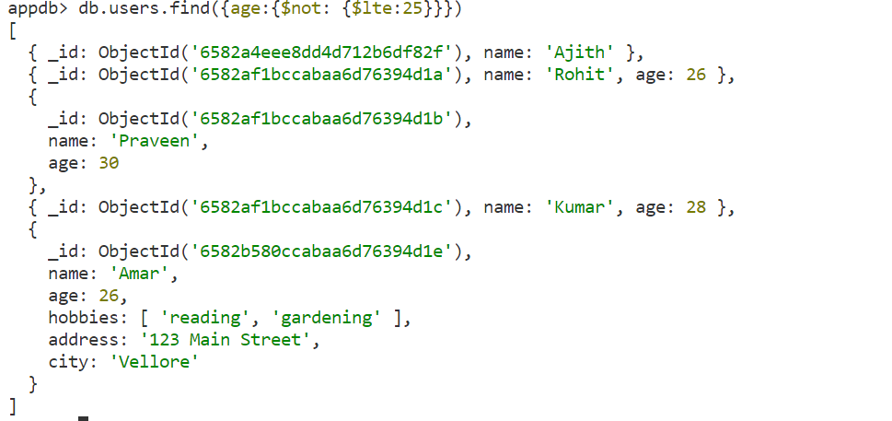



1. **Comparison**

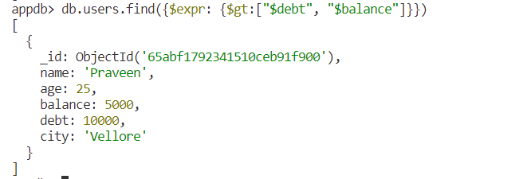**Debt greater than balance**



**findOne**

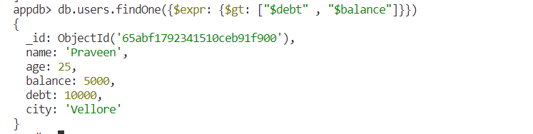



**Find based on complex object values**

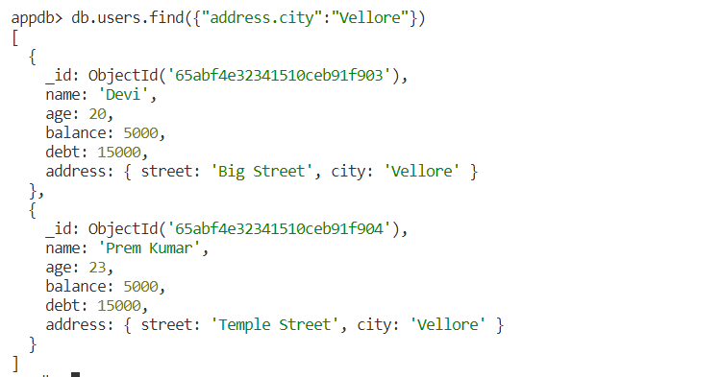



1. **Count Documents**













1. **Update**
2. **UpdateOne**

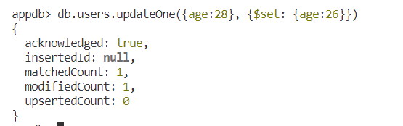



1. **Increament**

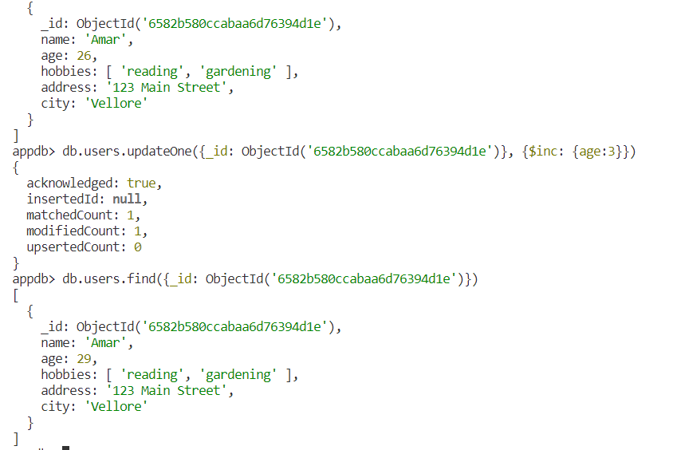



1. **Property Rename - $rename**

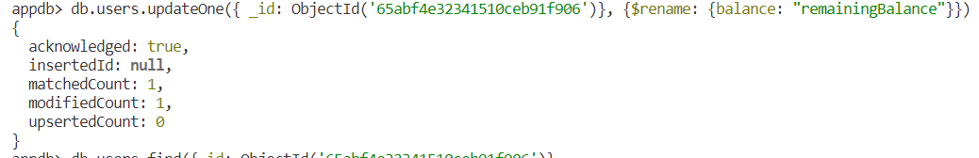



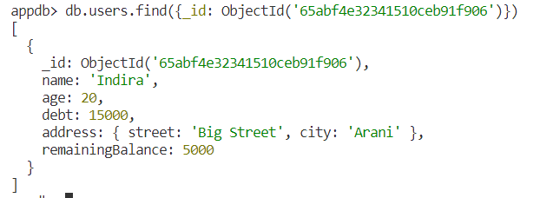

1. **Array add - $push**

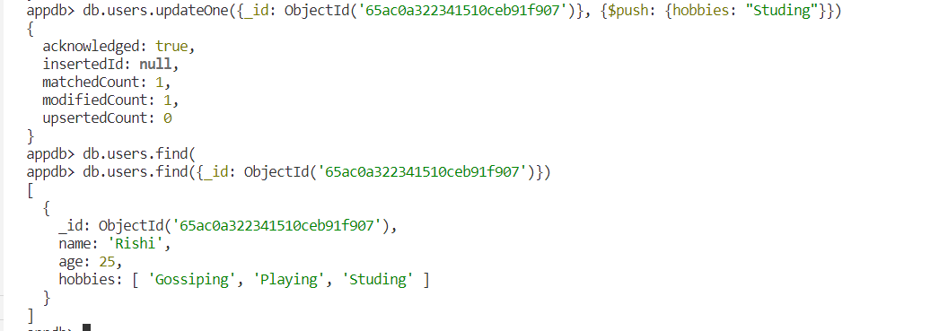



1. **Array remove - $pull**

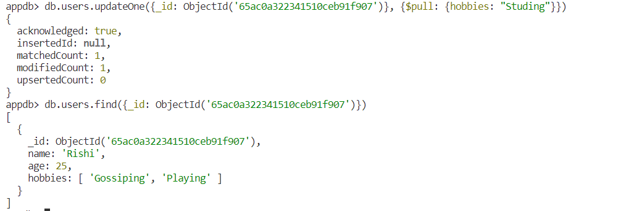



1. **Delete property - $unset**

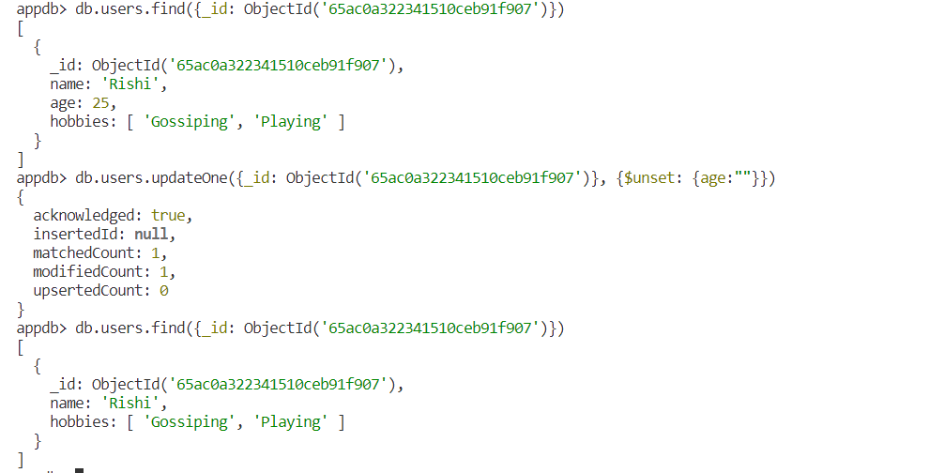



1. **Delete property of all document**

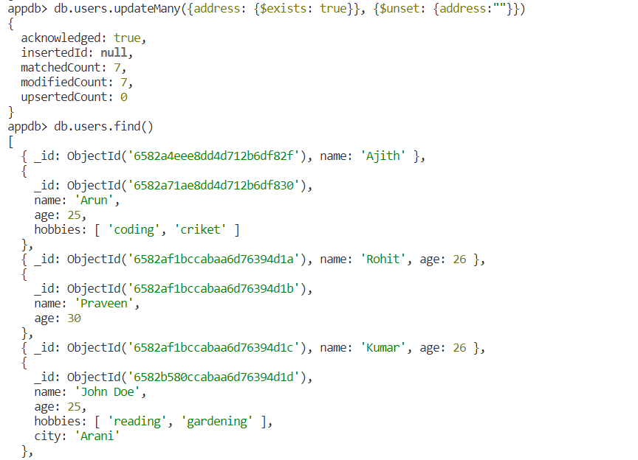



1. **Replace**
2. **ReplaceOne – delete everything rest of replaced value of a document**

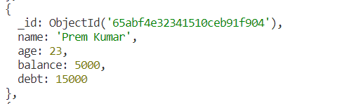

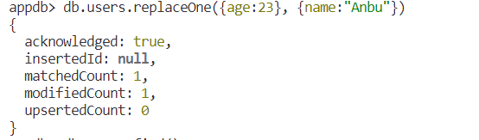





1. **Delete**
2. **deleteOne – delete one document**

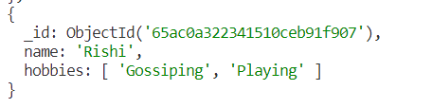





1. **deleteMany – delete Many document**





1. **Drop database**

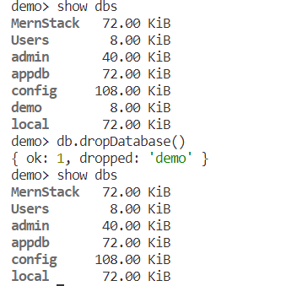



**Mongoose**



**Model**

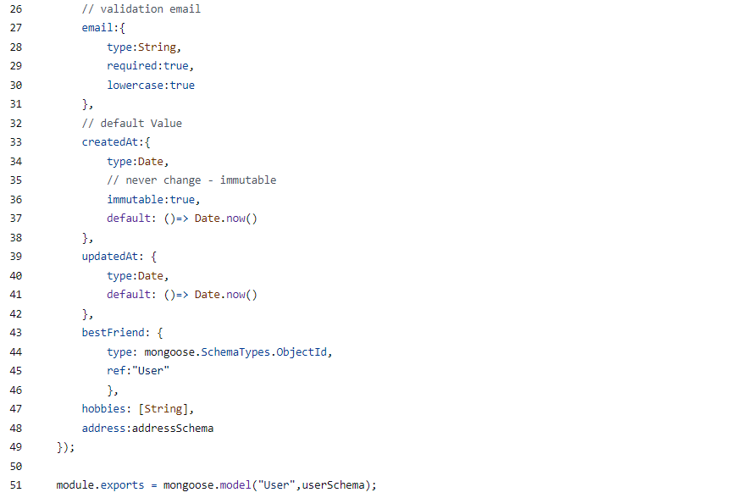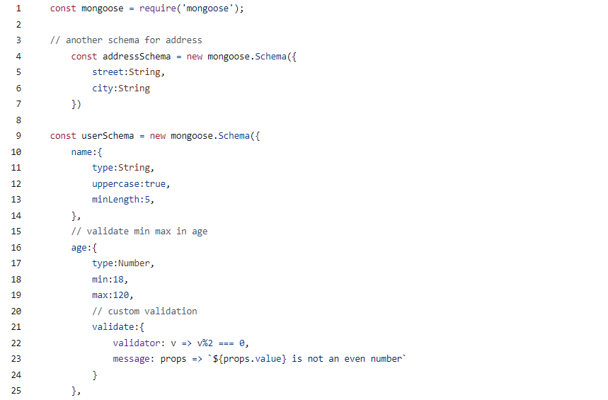

Script.js

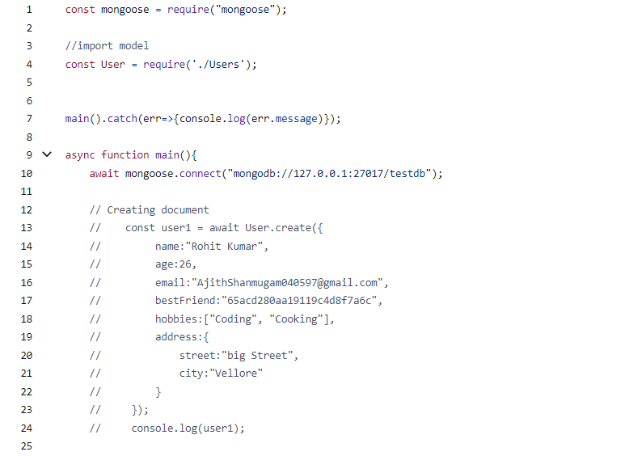

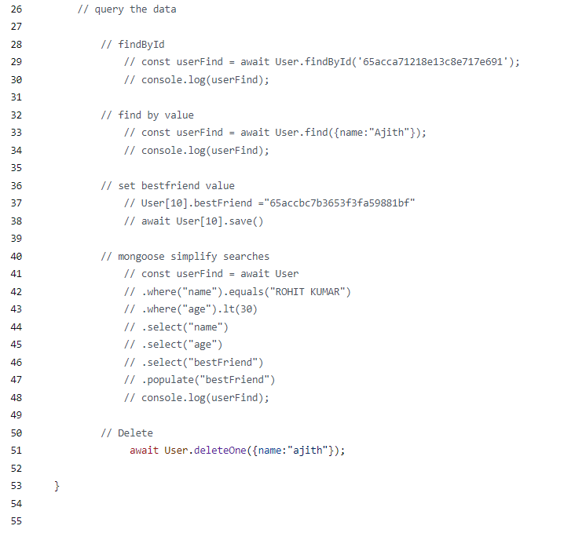

**Advance concepts**

1. **Function declaration in model**

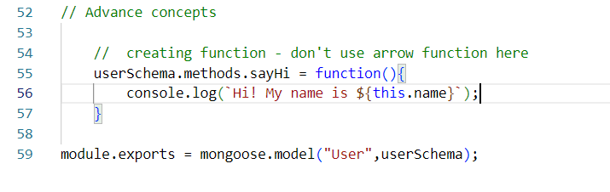

**Script.js**

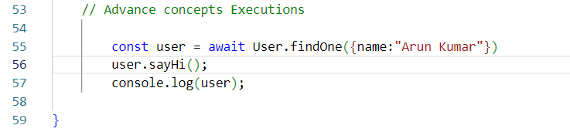

**Output**

